Project Deliverable B: Business Model Canvas and DFX GNG 2101
University of Ottawa
Group: Card mount

Objective:
This deliverable's objective is to create a potential business model well suited to commercializing this product, develop a canvas, and identify potential social and environmental benefits and costs. Finally, identify five important X factors in developing your product.

B.1.1: Business model and sustainability report
The value proposition that our team brings to the table is an extremely user friendly, easily usable and adaptable card/iPad mount for wheelchair users. The reason for this choice is that our client and user are our number 1 priorities, and our group must assess according to our demographic of users. In this scenario our immediate user has problems with accessibility and overall comfort and ease of use is the best way to offer comfort and joy in our product given that moving around physically wheelchair is slightly difficult and may be uncomfortable for the user. Thus, our product will ensure that this value will be delivered!

B.1.2: Business Model Canvas (added image and extras included below)
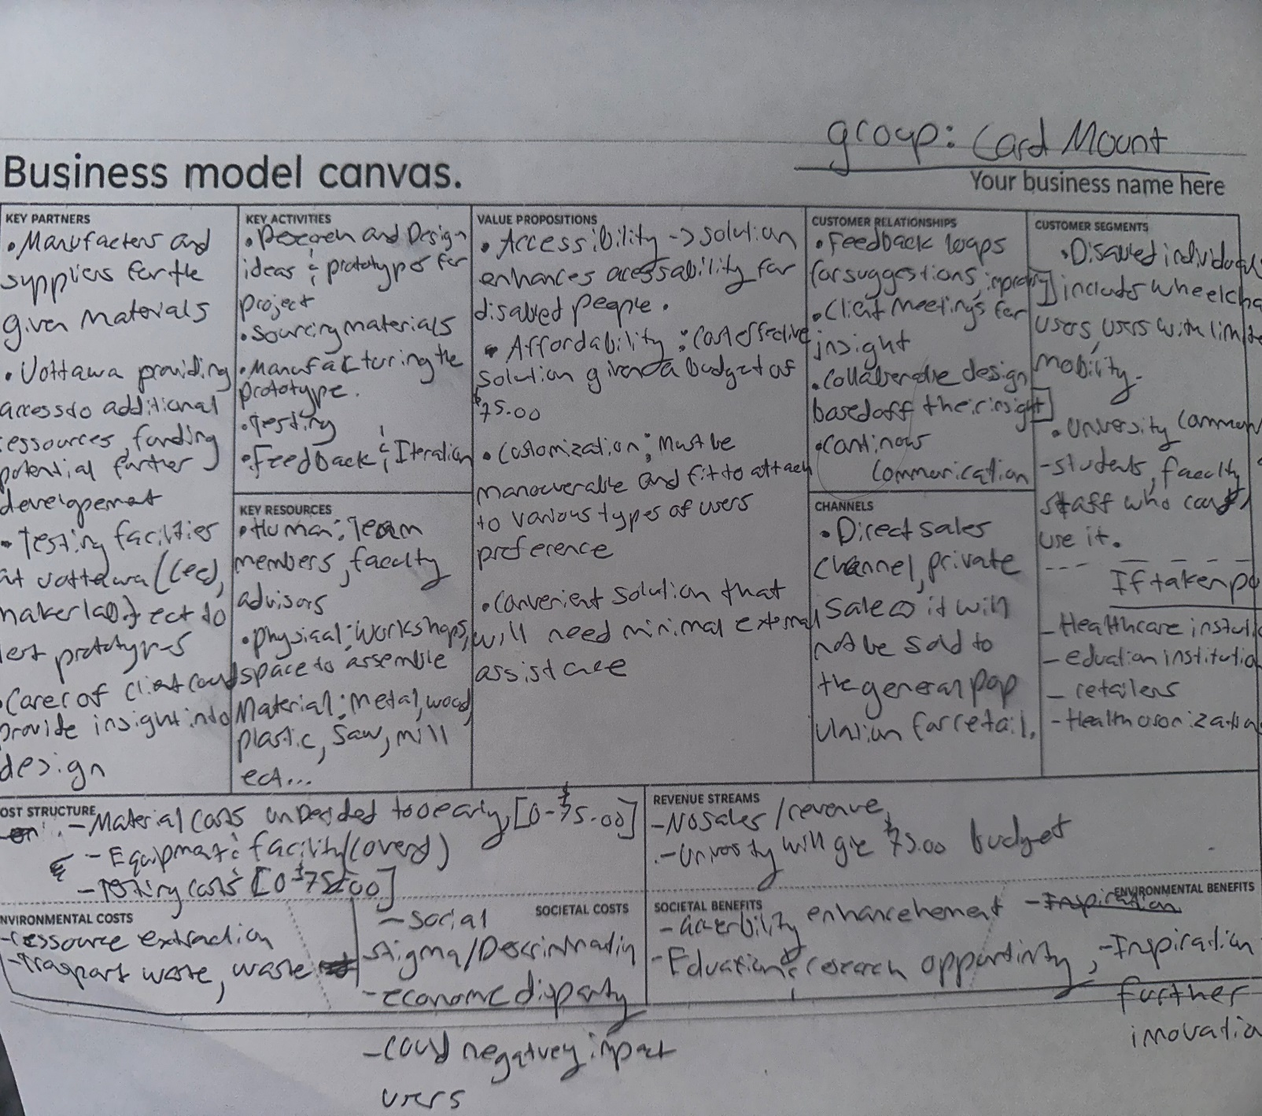 Extras’
Key Partners
University of Ottawa:
- Provide the initial balance of 75$
- Provide valuable information about how to build the business
Healthcare Providers:
- Provide communication between the client and the team
Key Activities
Product Development:
- Designing and refining the product
Manufacturing:
- Building and troubleshooting the device
Customer Support:
- Communicating with the client and troubleshooting the device for the client’s desires
Marketing and Sales
Key Resources
Design Team:
- Using the information learn in previous courses and personal experience to design the device
Manufacturing:
- 3D printers: some group members own 3D printers that can produce low strenght parts
- Workshop: The University will probably offer some time in the workshop to build more durable parts
Value Propopsition
Aesthetics: The device needs to follow the aesthetics desires of the client
Installability: The device needs to be easy and simple to install and remove
Usability: The device needs offer a way to play multiple game types
Portability: The device needs to be easy to carry
Flexibility: The device needs to be ambitious
Customer Relationship
Feedback: Feedback from the client and user will be valuable
Channels
Direct to consumer: The team will talk directly with the client and user
Cost Structure
- R&D cost: Since the team will provide the R&D, it can be assumed null
- Manfacturing cost: Production machine will be provided by the team members or the University, can be assumed null
Revenue Stream
- Direct Sales: The money will come directly from the client

B.1.3: Core assumptions
Reflecting on our client demographic, this product will most certainly be oriented towards people with physical disabilities in wheelchairs, the specific disability is not of importance if the product can be installed and used. But this product is not limited to only that demographic, as this device can be really attached to anything such as a table, bed etc. thus anyone can use this for their own comfort or preferences. While there are certain products like this which exist the competition for this domain regarding our specific demographic will be little. Another assumption is that it will be sold in masses as well as singles to either hospitals or general locations that harbor many people with physical disabilities. Thus, production of this product must be easy, and assembly must be rather easy or pre-assembled with some type of re-assurance for build quality to be proper. Another assumption is that this product will be able to last a good amount of time as it is not something you should be swapping out often thus our product will be extremely sturdy but feasible for use over long periods of time and able to withstand physical abuse from drops, scratches etc.

B.1.4: Sustainability Report and Tripple Bottom Line
Social Impact
Positive Impacts:
- Accessibility: The device will aid those with disabilities or people with limited dexterity, allowing them to participate in card and board games. This inclusivity can enhance interaction and quality of life
- Community: By making games more accessible, it will increase interaction within the building, making residents engage in shared recreational activities.
Negative Impacts:
- Production: If the card mount device is brought to a larger market, the manufacturing process might be achieved with poor labor practices which will contribute to social inequalities and worker exploitation.
Environmental Impacts
Positive Impacts:
- Material Choice: The device's material choice can drastically change its environmental impacts. If recycled materials are used, it can reduce its environmental footprint and support conservation of resources while reducing waste.
- Durability: If the device is well built with strong parts and replacement parts, it can increase the lifecycle of the device.

Negative Impacts:
- Manufacturing Emissions: The manufacturing process might involve environmental emissions; this includes the emissions from the extraction of the raw materials (where recyclable material cannot be used) to the energy used to produce the device.
Economic Impacts
Positive Impacts:
- Job Creation: The production of such a device can create jobs in manufacturing, design and sales. It can create jobs locally but also globally if the production is brought elsewhere.
Negative Impacts:
- Cost of sustainable practice: Implementing sustainable materials and production can increase production cost, which will subsequently increase the price of the device. This can reduce its available market since most consumers come from vulnerable populations and lower-income groups.

Finacial  Balance Sheet | Human / Social  Balance Sheet | Environmnetal  Balance Sheet
Income  - No Income  - Initial Balance: 0$ | Positive Outcomes  - Help those with disability  - Increase interaction within the community | Positive Outcomes  - Recyclable materials – help with the environment and sustainability  - Durable materials and replacement parts – increase lifecycle of the device
Expenditure  - Excepted Cost: 75$  - Balance: -75$ | Negative Impacts  - Manufacturing process might include poor labor and harsh conditions | Negative Impacts  - Manufacturing emission; emission form raw materials extraction and energy for manufacturing
Profits  - No Profits  - Final Balance: 0$ | Net Social Benefits  - If the manufacturing can be controlled / supervised, the benefits from the device will overshadow the labor conditions | Net Environmental Benefits  - If the majority of the device can be made from recyclable materials (or thermoplastic polymers, and metals), and the factory operate on renewable energy, the impact on the environment will be negligable

B.2 Design for X
- Design for Aesthetics:
The client is a very big fan of Disney and made it clear that the product should be designed towards Disney princesses or themed with Disney aesthetics. This means that the solution should have some Disney colors – pink or candy blue – and/or have decals and pictures of Disney princesses.
- Design for Installability:
The client needs the device to be mounted on the chair since she plays at a specific distance from the table but needs the chair clear from any mount since she needs it for daily tasks. Hence, the device needs to be installable on the chair and be easily removable with little to no effort.
- Design for Usability:
The client plays various games such as Skip-Bo, Scrabble, make puzzle and needs it to hold her tablet. Hence the device needs to hold various types of shapes, sizes and loads for the multitude of games the client will use.
- Design for Portability:
As mentioned previously, the client will use her chair for daily tasks. As well as the installability, the portability of the device needs to be very easy. The client has a caretaker, and they need the device to be easy to move and store for future use.
- Design for Flexibility:
The client mentioned that she likes to play with her left hand. Although, it is fair to assume that for some games, she will need her right hand. Hence the device will need to be ambidextrous, so the client – or any other users – can use the device without any constraints.
Conclusion:
In conclusion this document outlines the transition into thinking and developing into more of a business-like mentality and establishing our key core assumptions through usage of team discussions and tools like the triple bottom line discussing financial, social, and environmental pros and cons, and discussions with our client. Finishing off the document highlights the identification and justification of five critical design factors based on research and client meet and feedback received

Project Deliverable C: Problem Definition, Concept Development, and Project Plan
GNG 2101
University of Ottawa
Group: Card mount
Objective
Go through the problem definition and concept development processes and create a plan for completing multiple prototypes in time for Design Day.
Instructions
This project deliverable is split into three parts and will require a lot of work from all members of your team. To be successful, you will need to start early.
C.1 Problem Definition
Client Needs:
# | Customer Needs | Specifications | Importance
1 | Helping hand | Hold her hand of cards and her iPad | 5
2 | Is not in the way | Mount is easily removable | 4
3 | Works with her environment | Must be able to mount on her wheelchair table | 5
4 | Is esthetically pleasing | Is Disney themed | 3
5 | Must be able to be adjustable | The mount must be able to move freely in x, y, z | 3
6 | Must stay in place | Must be able to withstand the weight of mounted device | 5
7 | Must be easy to use | Setup is quick and easy | 4

Problem Statement
Due to limited hand dexterity, a woman struggles to hold her playing cards in her hands. She must be able to access her wheelchair table when necessary and would like to be able to mount her iPad when the cards are not there. Our provided solution will be a form of mount with an interchangeable end effector, that can be adjustable in position and that can be removed if need be.

List of Metrics
Metric # | Associated Need | Metric | Importance (x/5) | Ideal/Target values | Unit
1 | 6 | Allowable holding weight | 4 | 1 | kg
2 | 2 | Minimum size | 3 | 20 x 10 x 3 | cm
3 | 3 | Clamp force | 5 | 50 | N
4 | 5 | Reachable length | 3 | 50 | cm
5 | 7 | Time to set up | 2 | 60 | sec
6 | 1 | Number of cards | 4 | 25 | cards
7 | 7 | Ease of use | 3 | Very easy | N/A
8 | N/A | Cost | 4 | 75 | $

Benchmark on Metrics: Competitive Products
Metric # | Associated Need | Metric | Imp. | LISEN Tablet Stand [1] | Desk-Mount Tablet Arm [2] | Vivalla tablet stand [3]
1 | 6 | Allowable holding weight | 4 | 5 | 5 | 5
2 | 2 | Minimum size | 3 | 4 | 2 | 3
3 | 3 | Clamp force | 5 | 1 | 5 | 1
4 | 5 | Reachable length | 3 | 4 | 5 | 1
5 | 7 | Time to set up | 2 | 4 | 2 | 5
6 | 1 | Number of cards | 4 | 1 | 1 | 4
7 | 7 | Ease of use | 3 | 4 | 2 | 5
8 | N/A | Cost | 4 | 5 | 1 | 5

Target Specifications compared to Competitive Specifications
Metric # | Associated Need | Metric | Imp. | Unit | Ideal Design | LISEN Tablet Stand [1] | Desk-Mount Tablet Arm [2] | Vivalla tablet stand [3]
1 | 6 | Allowable holding weight | 4 | kg | 1 | 5 | 0.5 | ~10
2 | 2 | Minimum size | 3 | cm | 20 x 10 x 3 | 17.81 x 12.46 x 3.4 | 16.76 x 9.65 | 26 x 16 x 17
3 | 3 | Clamp force | 5 | N | 50 | N/A | 50 | N/A
4 | 5 | Reachable length | 3 | cm | 50 | 40.39 | 80.77 | 0
5 | 7 | Time to set up | 2 | sec | 60 | ~ 60 | ~ 120 | ~ 10
6 | 1 | Number of cards | 4 | cards | 25 | ~ 3 | 0 | ~ 20
7 | 7 | Ease of use | 3 | N/A | Very easy | Easy | Difficult | Very easy
8 | N/A | Cost | 4 | $ | 75 | 24 | 176 | 16

C.2 Concept Development
- Based on your problem statement, develop final prototype concepts for each subsystem, as well as the entire assembled system required to solve the problem.

Concept 1:
A 3-DOF arm will be attached to the communication board using a C-clamp. The arm itself will have three joints to allow it to move from side to side (x-axis), back and forth (y-axis), and up and down (z-axis). The mount at the end of the arm will consist of a plate with a with a little ledge at the bottom to hold the cards/tablet (similar to the letter racks in scrabble).

Concept 2:
A 3-DOF arm will be attached to the communication board using a C-clamp. The arm will have three joints to allow it to move up and down (z-axis), one to turn towards and away from the user (radial), and one to tilt the mount up and down depending on the mount’s preferred position. The mount at the end of the arm will consist of a plate with a with a little ledge at the bottom to hold the cards/tablet (similar to the letter racks in scrabble).
- Analyze and evaluate all concepts against the target specifications you defined. Use simple calculations and/or simulations to make decisions. Justify the process and methods used for analysis and evaluation.
Concept 1/2:
Specification 1: The concept includes a removable mounting device to hold her ipad or cards. Different mounts will be created so that they can be interchanged for different usages. For example, a mount will be created to hold the ipad and another will be created to hold cards. Having interchangeable mounts avoids the additional design and construction of 2 or 3 other whole systems to complete slightly different tasks.
Specification 2: The concept includes a C clamp which will clamp onto the base of the wheelchair table. A C clamp is used because it allows the user to clamp the system onto any desired location of the wheelchair table. In addition, C clamps are simple devices that are easy to use for most mobility levels. Lastly, C clamps offer enough clamping force to hold the system in place. Most clamps have a clamping force in the hundreds of pounds which will be more than enough to keep the system stable and in place.
Specification 3: Two different factors contribute to the system working with her environment. First, the clamp allows the user to easily place the system in the desired location according to her environment. Second, different joints on the system will be used so that the user can change the direction of the system according to her environment. Therefore, if there are significant changes to her environment that oblige her to move the system these two factors can be used to do so easily.
Specification 4: Due to the small number of moving parts of the system, esthetic changes such as pictures, stickers, glitter glue... can be added to multiple surfaces by the user without hindering its performance. Doing so makes the system significantly more enjoyable for the user to employ.
Specification 5: The addition of three different joints will allow the system to move in the x, y or z axis. The design of these joints will be made so that changing they're angles does not require very much force or require a large amount of force, which would be hard for the user due to their limited mobility.
Specification 6: When designing the system, a clamp with the sufficient clamping force will be used. Most C clamps sold at stores offer clamping force in the hundreds of pounds, which will be more than enough to hold the system in place. Below is a sample calculation showing the required torque to hold the system in place for several sample values. It shows that the clamping force required is much smaller than what is commercially offered.
Sample torque used to hold ipad = R*F*sin = 0.30*0.68*9.8*sin(45) = 1.41 N < < 2227.27 N (sample clamping force from standard clamp)
R= Sample lever arm distance = 0.30 m
F= Force = weight of ipad = 0.68kg*9.8
= Sample angle = 45 degrees
Specification 7: Several parts of the concept allow the system to be easy to use. First, the C clamp allows the system to be easily placed on and off of the wheelchair board. Second, joints will be added to increase the range of motion of the system with little force and mobility from the user. Third, the system will be designed with different esthetic parts to make the system less complicated to use (Ie. Red joints to show where to turn the system...).

- Choose one or a few promising solutions you wish to develop further based on your evaluation.
Based on the generation of concept ideas, the system will comprise of the following solutions for sub systems, which will be developed further:
-Clamping mechanism using a C clamp
-Different joints throughout the main shaft to allow for 3 DOF throughout the system
-Usage of different mounts to allow the system to hold different things. Only 2 configurations have been identified so far: card holder, iPad holder.

- Develop a global design concept which is either an integration or modification of the promising concepts chosen in the previous step, or a brand-new concept created from these ideas. Justify your approach.
The global design concept will integrate the best ideas from our initial concept:
- A C-clamp will serve as the base to be attached to the communication board.
- A 3-DOF arm will be used with 3 distinct joints to enhance mobility.
- A cross-shaped mount base will be found on the end of the arm to easily connect the different mounts onto the arm.
- Three main mount concepts are currently in the design:
  - A universal mount.
  - A card mount.
  - A tablet mount.

- Visually represent (sketch, diagram, CAD model, etc.) your global concept.
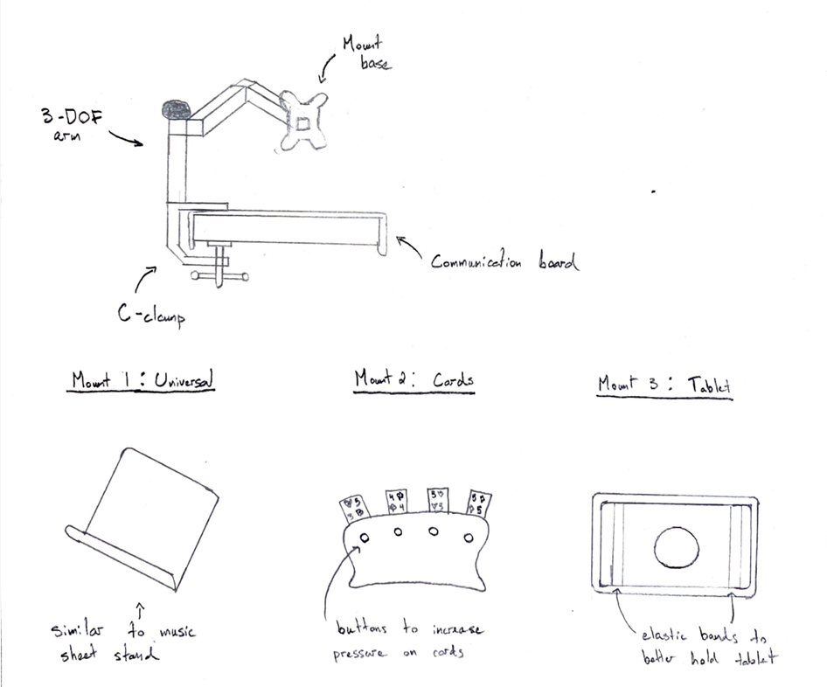
- Provide a few lines explaining your concept’s relationship to the target specifications, as well as its benefits and drawbacks.
The main goal of our concept is to fulfill all the needs of our client while making the design as user friendly as possible for different mobility levels. Using an easy mounting sub-system will allow the user to easily attach and remove the system at different locations. Integrating 3 DOF will allow the user to move the system in the desired position and having different configurations for the mounts will allow the user to use the system for a variety of different activities. Some of the potential drawbacks to this solution are: creating or buying mounts with the same configuration can be costly and complicated since every mount needs to adhere to the same configuration, which may not be physically possible or may be too costly in some cases. Secondly, the system will only be able to clamp onto one type of surface using a C clamp. Other types of flat surfaces which don’t allow for a C clamp won’t be able to use this system.
C.3 Project Plan. Starting with MS Project Plan you created in Project Deliverable A
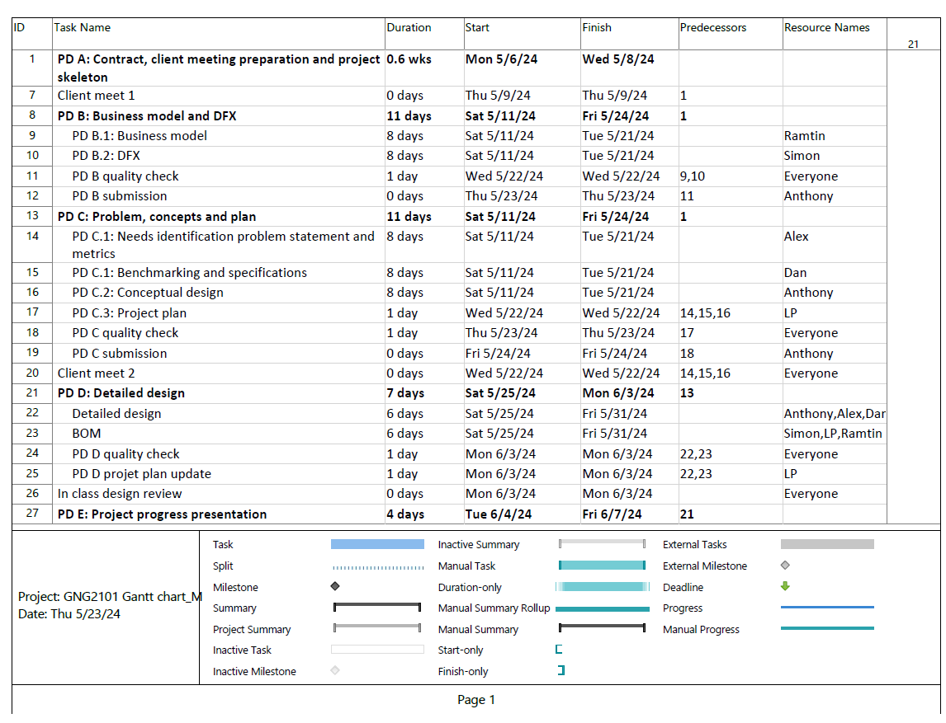
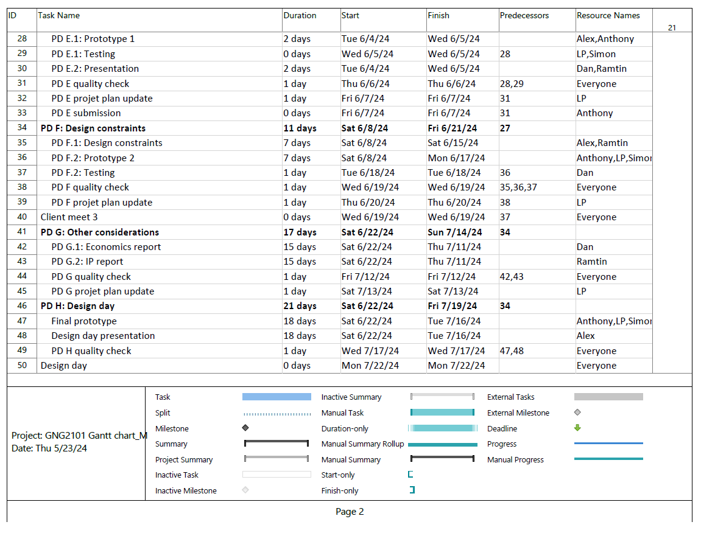
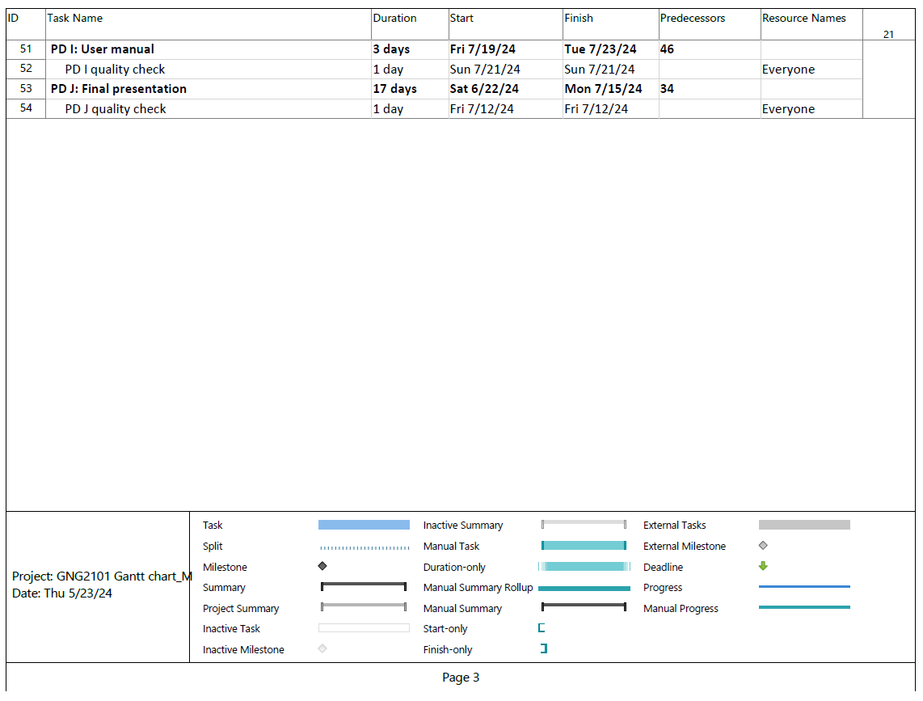
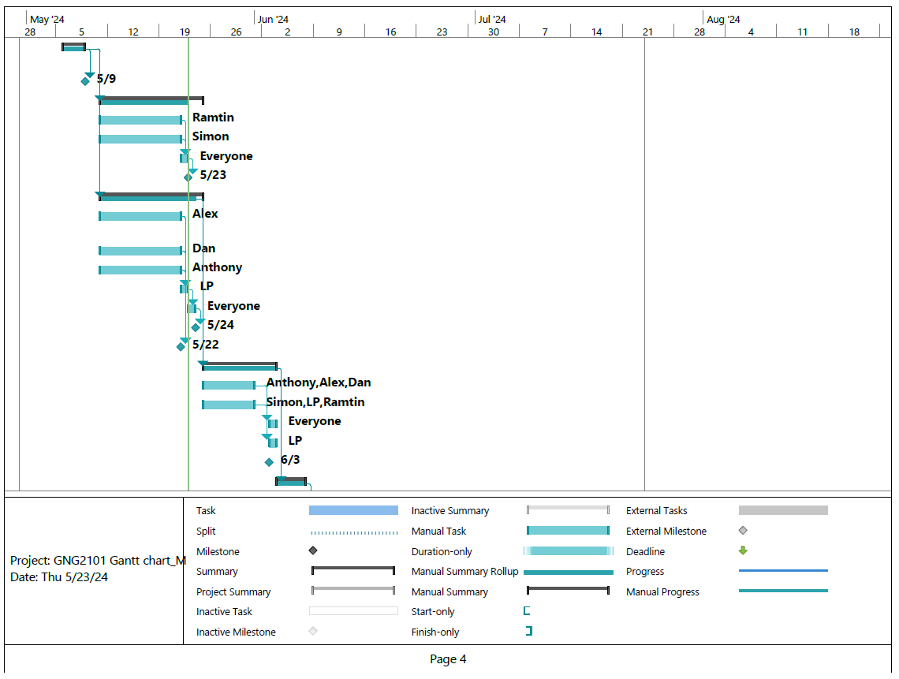
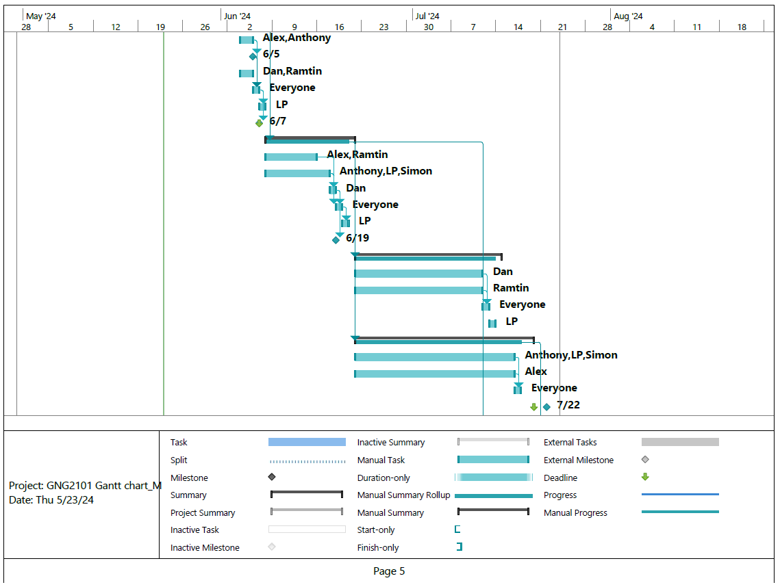
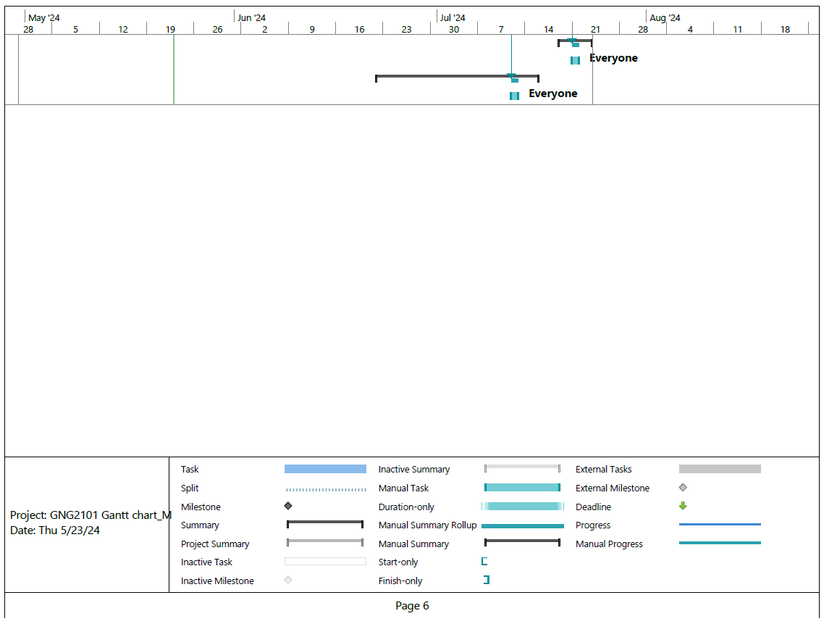

Bibliography
[1] N/A, N/A. “Lisen Tablet Stand for Desk, Adjustable iPad Stand Holder Portable Monitor Stand, Ipad 10th Generation Accessories for Office Kindle iPad Pro 4-15.5" : Amazon.ca: Electronics.” LISEN Tablet Stand for Desk, Adjustable iPad Stand Holder Portable Monitor Stand, iPad 10th Generation Accessories for Office Kindle iPad Pro 4-15.5" : Amazon.ca: Electronics, 2024, www.amazon.ca/LISEN-Adjustable-Portable-Monitor-Essentials/dp/B0BTDHQJ6X?ref_=Oct_d_obs_d_3341401011_2&pd_rd_w=XNzxw&content-id=amzn1.sym.cb374c46-3b5e-40a3-887b-3d3df2ac71f9&pf_rd_p=cb374c46-3b5e-40a3-887b-3d3df2ac71f9&pf_rd_r=Y67Q1JPBBTNTWNNWAN9R&pd_rd_wg=tRRI1&pd_rd_r=b46ca776-b263-4e24-a570-08e51703b75b&pd_rd_i=B0BTDHQJ6X&th=1.
[2] N/A, N/A. “StarTech.Com Desk-Mount Tablet Arm - Articulating - for 9″ to 11″ Tablets - Ipad or Android Tablet Holder - Lockable - Steel - White.” Comkex.Com, 16 May 2024, comkex.com/product/startech-com-desk-mount-tablet-arm-articulating-for-9-to-11-tablets-ipad-or-android-tablet-holder-lockable-steel-white/?srsltid=AfmBOopFnWG2Co2Hbp7n1U2G99tzN1tILo5ZNCfDT-axDQGMhcUg3_ny9-4.
[3] N/A, N/A. “Vivalla Tablet Stand, Bamboo, 26x17 Cm (101/4x63/4") - Ikea Ca.” IKEA, 2024, www.ikea.com/ca/en/p/vivalla-tablet-stand-bamboo-60515789/?utm_source=google&utm_medium=surfaces&utm_campaign=shopping_feed&utm_content=free_google_shopping_clicks_Homeorganisation.

Project Deliverable D: Business Model Canvas and DFX GNG 2101
University of Ottawa
Group: Card mount

Objective:
The objective of this deliverable will be to provide design details for our concept and reflect on its feasibility. Other objectives are to assess our feedback given by the client and develop a detailed design of our prototype, determine the realistic time frames needed to complete the deliverables and physical prototypes of the project and discuss available resources and skills needed to accomplish these goals. Finally, we will develop a bill of materials and parts (BOM) for the final prototype.

- During the second client meeting our group developed multiple prototype samples in which the client approved of all designs, with minor changes. An example of positive feedback received was the amount of detail in our prototype samples. No direct constructive criticism was given to our group but after asking a question the group deduced that the aesthetic component of the design would play a more significant role in the overall enjoyment of the product. Overall, the client was extremely happy with the level of preparedness and our vision as they did not expect such detail.

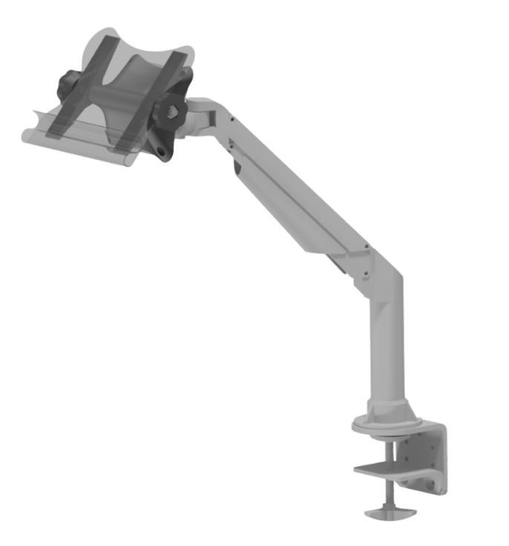

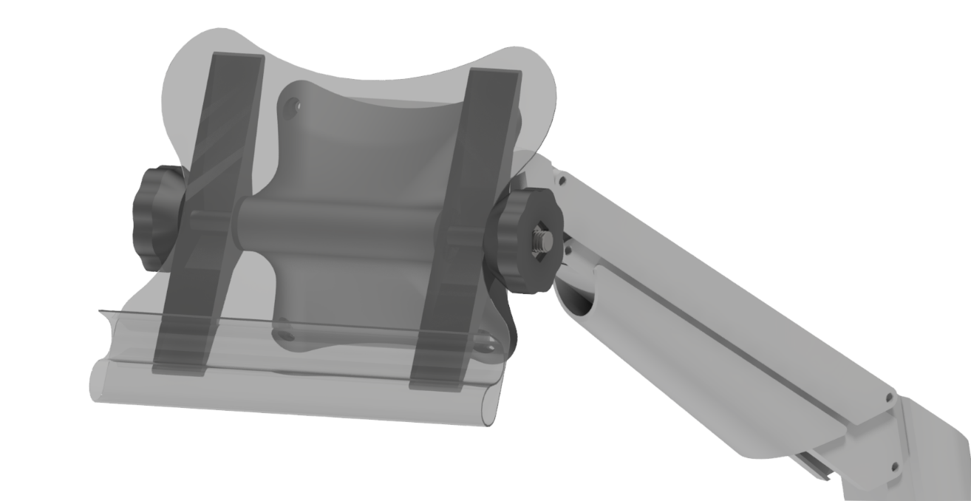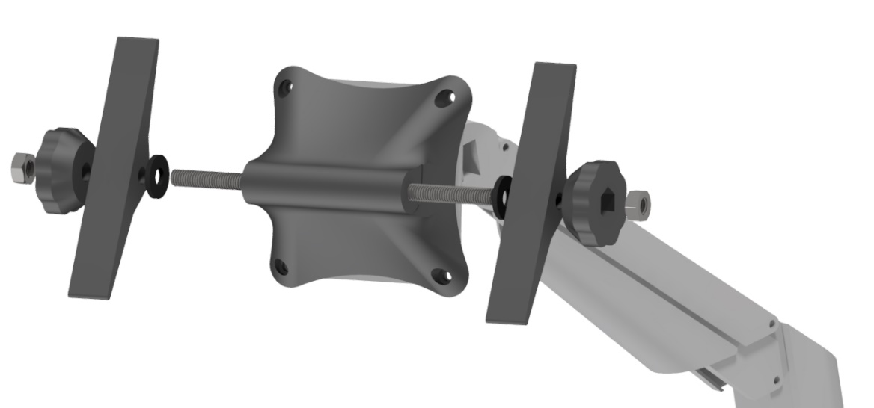

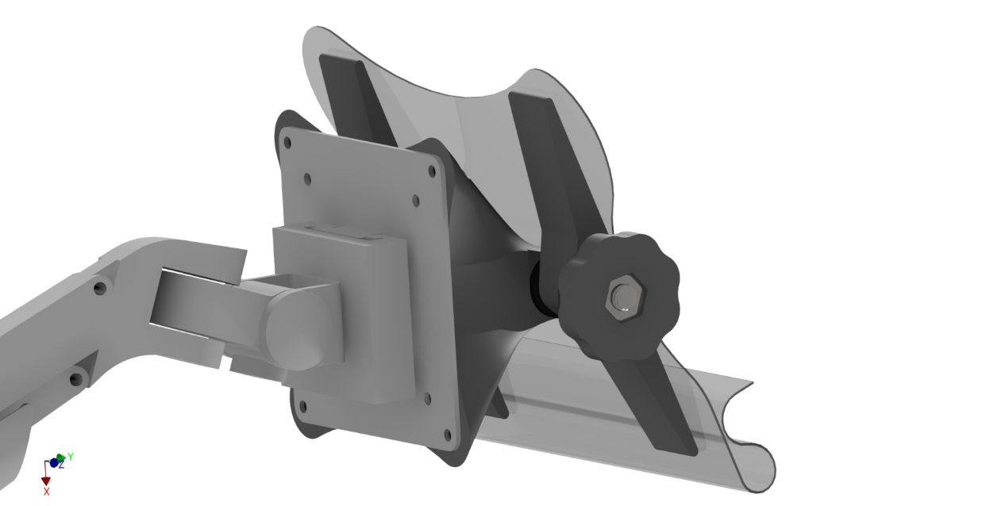
Our design is mainly built around a computer monitor arm. We chose to use this since it satisfies our needs very well, in the way it can be manipulated very easily to many positions and simply stay there when let go. It has two “elbow” joints that can move the end interface up and down, able to reach the table on which it will sit and a height of about 30”. It has a clamp on the bottom of the arm which can be screwed on tightly to any table’s ledge. At this joint, it has 360$°$ yaw rotation ability and at the end interface, has a joint able to rotate (again, about the vertical axis) up to 180$°$. The aforementioned capabilities of the arm are already implemented in the purchased model. However, we have designed and end interface which will be able to tilt and lock into place. This tilt system will be achieved using a threaded M10 shaft, along with 2 M10 nuts which will be heat set into 3D printed knobs. This interface connects to the already installed face plate on the end, which will be fastened using M5 bolts and nuts. These pieces are the black colored pieces in the renders above. Finally, a sheet of HDPE (high density polyethylene) will be purchased and heat molded into the shape seen in the renders above. This will be done using a heat gun and 3D printed molds to achieve a more accurate mold. This curved design allows for cards to be placed and help tightly in the bend on the bottom. The lip on the end of this bend also acts as a lip on which an iPad can be placed.

- Our group possesses a variety of skill sets and an incredibly positive attitude towards producing our project. Five of our group members are soon to be graduating mechanical engineering students who have vast experience and knowledge in durability, mechanics and structure of materials and will lead the physical prototype development and rigorous testing. Our 6th member is a first-year electrical engineer who does not have much knowledge or experience but is very eager to help and determined to complete any task given. In terms of resources, each member has a personal computer and the required software's to complete CAD prototypes. Additionally, we possess 3D printers and vehicles at our disposal if there is a need to transport and acquire any raw materials. The makerspace and ceed labs are also useful resources that we can use. Finally, the Ta’s assigned to this course are going to be extremely helpful in guiding us to ensure we’re on track and able to achieve our prototypes successfully. As for as this project, there are no additional skills needed as we are confident we can accomplish every aspect without acquiring new skills. However, each member is open to learning new skills if there is a need to do so. If need be, we can always ask our peers or research on the internet to find what we need or any new skills. All in all, our group has a linear plan and is ready to commence.

- Our group members will be splitting up the tasks based on our availability outside of the project but will always be available to work together if the group is falling behind or one of the members need help. We will be following the milestone goals to achieve our prototype building and deliverables which so far is on track and have had no worries or disputes on the subject. On average, we were able to complete our deliverables within a day or 2 of working on them and given 7 days according to the milestones. In terms of physical building of prototype and sketching we are assuming that one meetup per week to discuss our progress so far with an additional meetup to build the prototype that week, if need be, rotating members depending on availability. So that comes out to a total of 2-4 hours of week including meetups and building x 6 weeks from the day this was written would equate to a total of 12-24 hours with at minimum 3-4 members to complete the physical prototypes and deliverables to be completely on track. We will have a detailed idea of our prototype for this deliverable and assume beginning of building of the prototype 1 week from the due date of deliverable D (around June 10th) to have at least our first prototype started on track and close to being finished. In between we will be adjusting and ideally have our end prototype completed by June 24th or us after final client meet to be ready for our design day the week after.

- There are several other assumptions in our other deliverables that could affect our ability to implement our design. First, the bottom of our design includes a C clamp which clamps onto the edge of the table. However, if the table has an edge or any other inconsistent surfaces it could affect our ability fix our prototype in one place and therefore, we would not be able to hold cards or an iPad. The second assumption which could have an effect is the dimension of the iPad that needs to be held in place. During our client meet we did not get specific dimensions for which we can design, meaning assumptions on the size of the iPad will need to be assumed – leaving room for error in the final design. Additionally, the location of the clamp is assumed to be on the side of the table. During client meets, we did not get explicit feedback on a specific location where the arm should be clamped. Therefore, the group is assuming that clamp can be clamped on the side of the table and/or any other spots on the table. This assumption could lead to problems in the future if the client decides that there is a specific spot where they would like to have the product, meaning that the group would need to possibly find a new solution to clamp down the mechanism in place. Lastly, the group is assuming that 3 DOF will be enough in term of range of motion for the mechanism to move in the required locations. Although more DOF give more options for the user to move the device in the desired location and that the likelihood for design issues later on is quite small, the group was never instructed on the amount of DOF necessary for the design and assumed that 3 DOF was enough to satisfy the needs of the client.

- Since our current design only requires us to manufacture parts using the 3D printer, the BOM is split into two parts: parts that will be bought and parts that will be 3D printed.

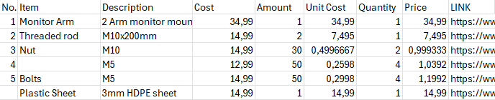

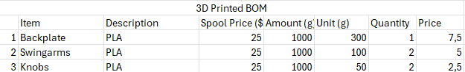

Project Plan Update

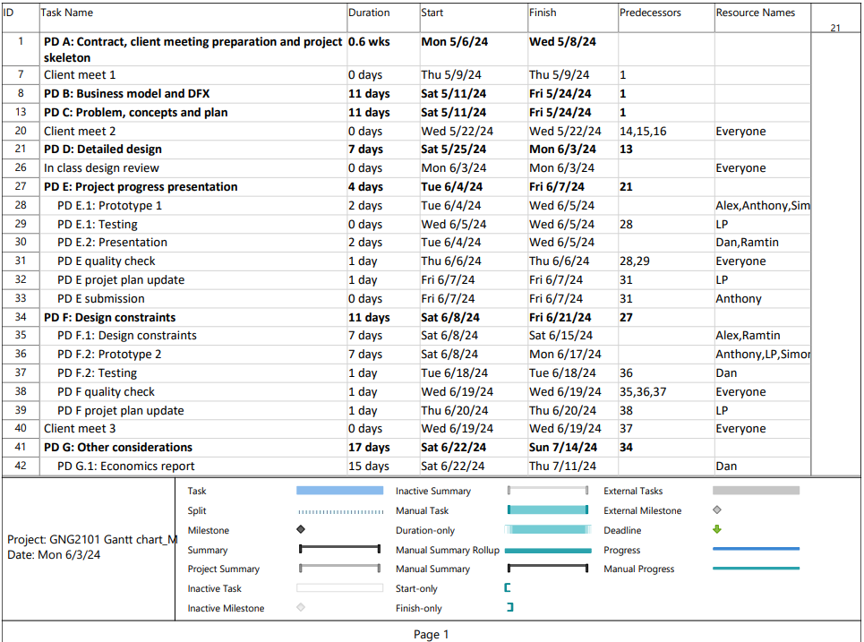
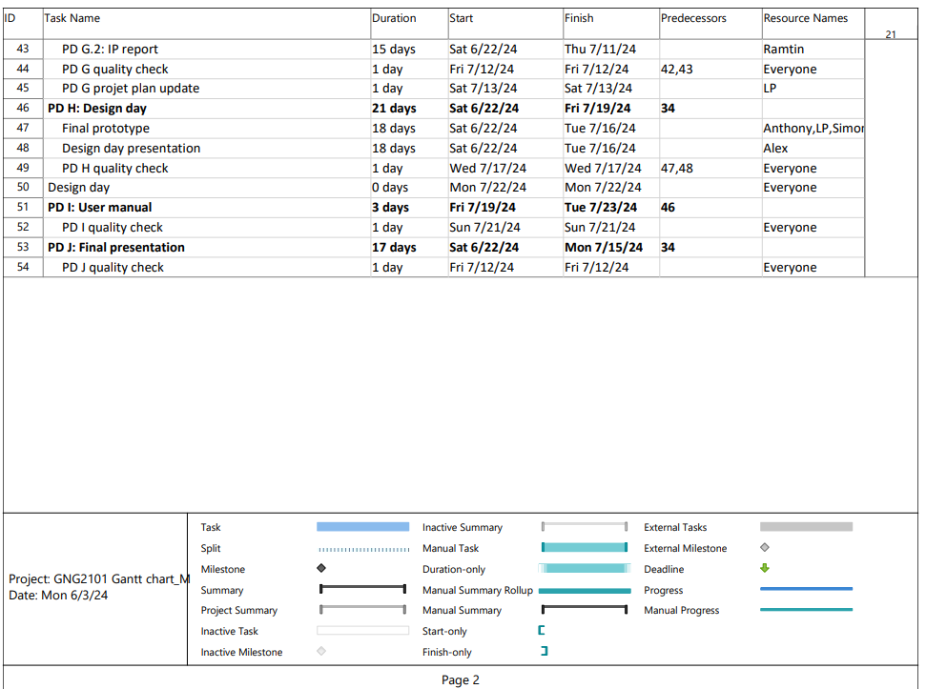

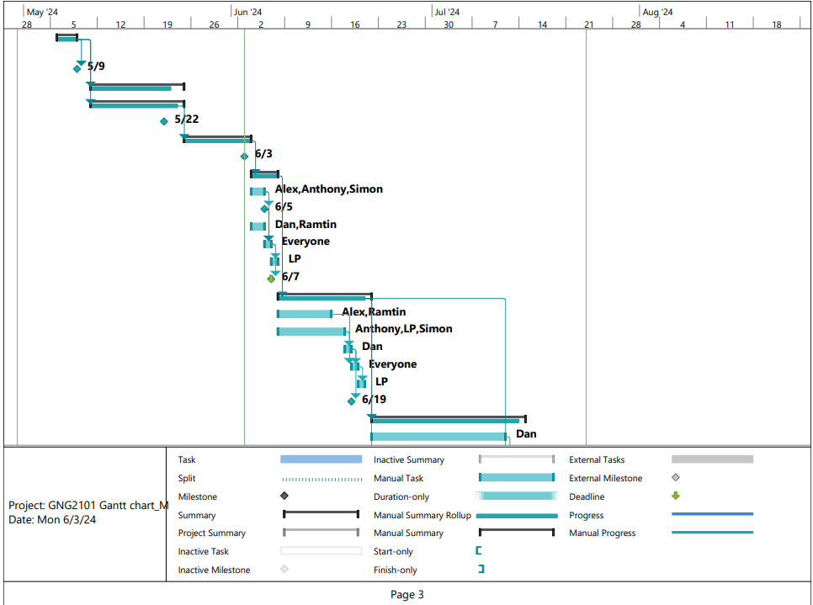

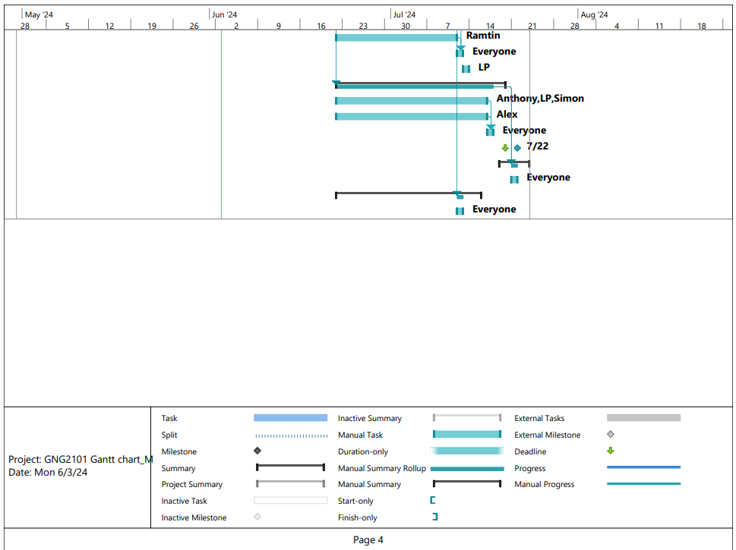

Project Deliverable F: Design Constraints and Prototype 2
GNG 2101
University of Ottawa
Group: Card mount

Objective:
Define two important non-functional design constraints and apply the DFX methodology to your design, develop new prototypes iterations on our way to creating our final prototype. Project plan updates and new client feedback will also be summarized.

F1:
1) One non-functional design constraint that is very important to the client are the aesthetics of our prototype. This is very important as the client themselves told us that an aesthetically pleasing design would make the customer extremely happy and was the only feedback they gave us when the prototype was presented.
The second non-functional design constraint that we should consider in our prototype is the overall weight of the mount. As our client is not very mobile nor strong we should address this as a real concern to try to improve on and reduce the overall weight as much as possible. This can affect the client if they want to adjust the mount or even safety reasons if the mount falls it can cause damage to somebody or the floor.
2) The changes needed to satisfy the constraint are to make the mount more pleasing with colour and or stickers added on, there was mention that the client does like Disney so something along those lines will be considered. As far as the weight goes, we are always thinking of new ways to innovate and design our mount, but we can think about different type of material for the shaft and hollowing it inside out keeping the bare minimum on the shaft. And minimizing our pure metal components as the 3-d material like plastic is much lighter and would be advantageous for the situation of our client.
3) Proof for aesthetic is quite tough as there are no real calculations we can do but for the sake of it well make a goal of at least 3 stickers with pink or blue colour ways that we can attach to the mount in some way that's visible to the client. The only real way to test this constraint is through the customers satisfaction so that will be the test necessary

As far as the weight goes, we can take the initial weight of our first prototype and do some general weighing tests with our hands and see if the force to adjust the mount or move the mount is too much or just sufficient so that our client will be able to do it. A way to determine this is assuming if we simply use a few fingers and use about 30-50% of our strength will be able to adjust the mount. And for safety we can do a drop test from varying realistic heights such as chest level standing up, chest level sitting down and hip level sitting down to mimic different heights of use. Analyzing the durability to some degree as well.
4) Design has been updated to include the feedback from the client. The knob size will be adjusted, and the aesthetic of the arm has been determined by the user. The size of the clamp will also be adjusted to allow it to close fully over the lip of the wheelchair tray.

F2:
1) We presented the prototype to the client, and they mentioned they would prefer if the tightening knobs on the prototype were a bit bigger. They are afraid the user might have some difficulties tightening the knobs due to their small size. We have concluded that we should reprint the knobs bigger to provide more options to the client. They will be free to use them or to use the smaller ones as they wish. We also presented stickers and aesthetic changes to the user so that they could share their preferences. The client and user picked out Disney stickers that they preferred would be on the final prototype. We plan to add those stickers once we are done the final prototype and testing. We noticed that the clamp on the monitor arm wasn’t wide enough to close entirely over the lip. We will need to shave off some material from the clamp to allow it to fully close. Finally, we also presented the clipboard to the user and showcased its functionality. They seemed satisfied with the results.
2) Several critical assumptions relating to our prototype have not been tested yet. First, the durability of our prototype has not been tested. Since our group is in the conception phase of our product and we have not produced a fully working prototype yet, we have not completed any testing on the product yet. Therefore, the group is assuming that it will be satisfactory to any testing standards such as durability, flexibility, resistance to chemicals and any other material testing standards. This assumption is related to the usability in our DFX factors because if our product cannot withstand any mechanical stress or usage then it can be basically rendered useless.
The second biggest assumption that we are making is that the product will be able to be easily installed by our client’s caregiver or the client themselves. During the design process, the team came up with the most efficient concept that would meet the constraints of the environment itself. For example, a clamp is being used to install the arm on the wheelchair because it is the most cost efficient and simple design to complete this task. However, the team never considered if a clamp is a technology that is easily installed by someone who is not familiar with the product or who has mobility limitations. Therefore, this product assumption that was made is related to the install ability DFX factor because this assumption has to do with the ease of setup/installation of our product.
3) Refer to 4) and appendix for pictures and information on progress of our prototype.
4)
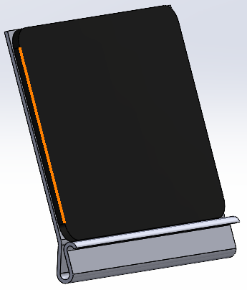
Figure 1 - Tablet resting on lip of the clipboard

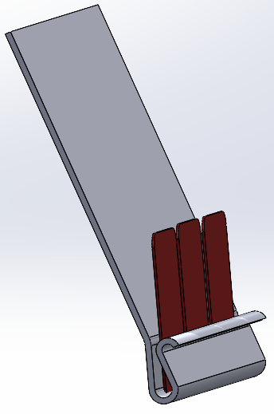
Figure 2 - Lip of the clipboard holding cards
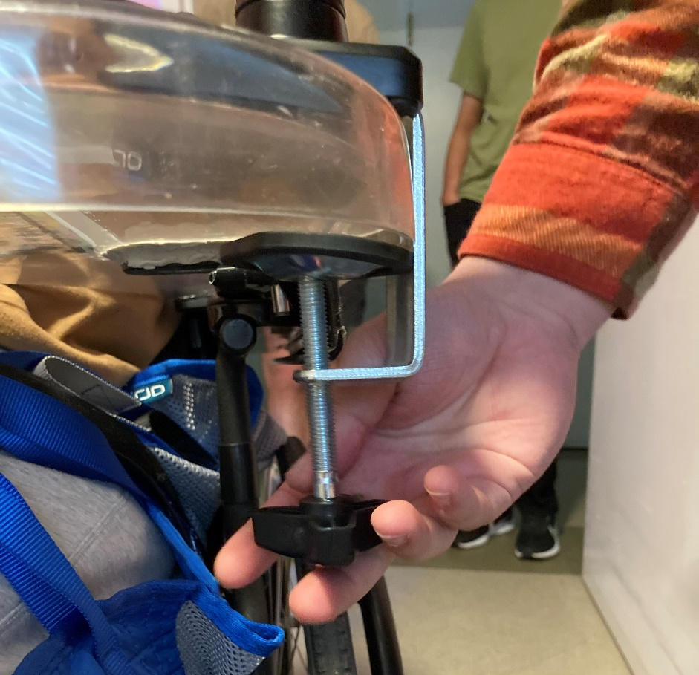
Figure 3 - Clamping mechanism over the wheelchair tray
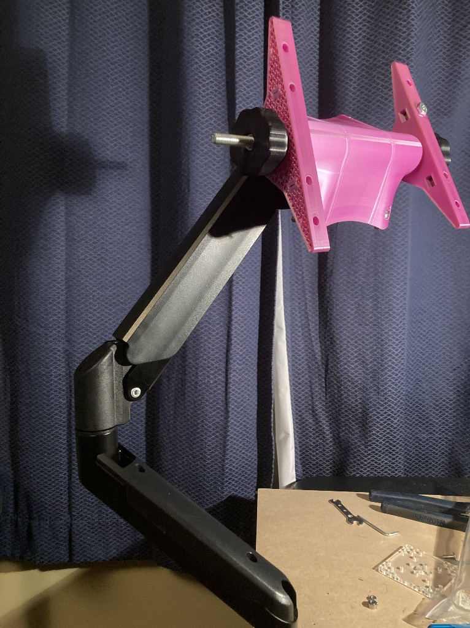
Figure 4 – Full arm extended with end attachment mount

5)
Table 1 - Prototype Testing and Target Specifications
Metric | Associated Need | Metric | Imp. | Unit | Ideal Design | Expected  Prototype | Prototype 2
1 | 6 | Allowable holding weight | 4 | kg | 1 | 10 | 6
2 | 2 | Minimum size | 3 | cm | 20 x 10 x 3 | 20 x 10 x 3 | 55 x 32 x 8
3 | 3 | Clamp force | 5 | N | 50 | 100 | 240
4 | 5 | Reachable length | 3 | cm | 50 | 60 | 63
5 | 7 | Time to set up | 2 | sec | 60 | 60 | 45
6 | 1 | Number of cards | 4 | cards | 25 | 25 | 20
7 | 7 | Ease of use | 3 | N/A | Very easy | Easy | Easy
8 | N/A | Cost | 4 | $ | 75 | 75 | 65

6) For our next client meet, our team intends to present the extend of our prototype to our client. Since our prototype is in the final stages of its development, we would like to try to show the installation process to our client so that they can get a sense of the usability of the product. Additionally, once it has been installed, we would like to test out the range of motion, clamping force and location of clamping as well as the interchangeable mounts to see if the clients' cards and iPad will be able to fit on the mount that has been designed. From this meeting the team would like to gather information on the general usability of the product. The most important information that will be asked are the ease of use as well as weight and installation procedure is so that we can see if any additional iterations to our product design must be made. Lastly, we would like to confirm which aesthetic components would be best for our client and would improve the overall enjoyment of the product.
Conclusion:
To conclude, we have summarized design constraints with 2 nonfunctional and backed it with tangible proof we can confirm these changes with. Also summarized our 3rd client meet with our new prototypes and methods of prototype testing we will prepare/have done before our final prototype.

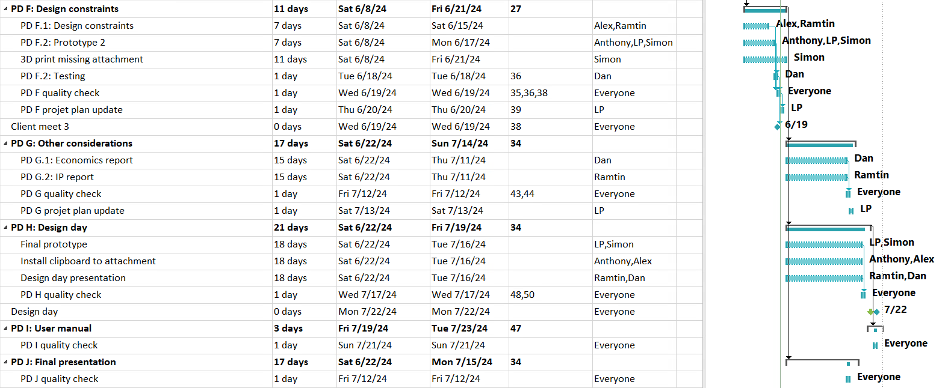
Figure 4 - Updated Gantt Chart (PD F to PD J)

Deliverable G: Other Considerations
GNG 2101
University of Ottawa
Group Z2.2: Card Mount

Objective:
Assuming you continue to develop your final prototype into an actual product, develop a forecasted income statement for your company based on the chosen business model. Finally, identify two intellectual properties that could act as legal constraints in developing your product or business.

G.1 Economics Report:
1)
 | Type | Indirect-Direct | Variable-Fixed
Monitor Mount | Material | Direct | Variable
PLA | Material | Direct | Variable
Threaded Rods | Material | Direct | Variable
Nuts | Material | Direct | Variable
Bolts | Material | Direct | Variable
HDPE Sheet | Material | Direct | Variable
3D Printers | Expense | Direct | Variable
Heat Guns | Expense | Direct | Fixed
Tools | Expense | Indirect | Fixed
Electricity | Expense | Indirect | Variable
Salaries | Labor | Direct | Variable
Rent | Expense | Indirect | Fixed
Advertising | Expense | Indirect | Fixed
Shipping/Handling | Expense | Direct | Fixed
Packaging | Material | Direct | Variable

2)
Card Mount Income Statement | Year 1 | Year 2 | Year 3
Revenue
Card Mount Devices | 155,125 | 155,125 | 155,125
 | 155,125 | 155,125 | 155,125
Cost of goods sold
Production Materials | 72,671 | 72,671 | 72,671
 | 72,671 | 72,671 | 72,671
Gross Profits | 82,454 | 82,454 | 100,704
Operating Expenses
Advertising Campaigns | 9,125 | 9,125 | 9,125
Electricity | 273 | 273 | 273
Utilities | 4,950 | 4,950 | 4,950
Salaries | 31,937 | 31,937 | 31,937
Overhead | 7,300 | 7,300 | 7,300
Investment | 13,300
Rent | 24,000 | 24,000 | 24,000
 | 90,885 | 77,585 | 77,585
Earnings before interest, taxes, depreciation and amortization (EBITDA) | -8,431 | 4,869 | 4,869

3)
Break-even analysis when the product is priced at 85$/unit:
$$PV=Adv.+Rent+Invest.+utilities+\left(overhead+salaries+electricity+mat.\right)*n≤n*sell price$$
$$PV=9125+24000+13300+4950+\left(4+17.50+0.15+39.82\right)*n≤n*85$$
$$PV=51375+61.47*n≤n*85$$
$$PV=51375≤n*23.53$$
$$PV=2183.38≤n$$
We must produce at least 2184 units to be profitable.

Break-even analysis when the product is priced at 90$/unit:
$$PV=Adv.+Rent+Invest.+utilities+\left(overhead+salaries+electricity+mat.\right)*n≤n*sell price$$
$$PV=9125+24000+13300+4950+\left(4+17.50+0.15+39.82\right)*n≤n*90$$
$$PV=51375+61.47*n≤n*90$$
$$PV=51375≤n*28.53$$
$$PV=1,800.74≤n$$
We must produce at least 1801 units to be profitable.

NPV Analysis at 85$/unit and 1825 units per year for 3 years (4% inflation):
$$PV1_{Exp}=9125+24000+13300+4950+\left(4+17.50+0.15+39.82\right)*1825=163,557$$
$$PV2_{Exp}=9125+24000+4950+[\left(4+17.50+0.15+39.82\right)/1.04]*1825=145,943$$
$$PV3_{Exp}=9125+24000+4950+[\left(4+17.50+0.15+39.82\right)/{1.04}^{2}]*1825=141,794$$
$PV1_{Pro}=1825*85=155,125$ $PV1_{Net}=155,125-163,557=-8,432$
$PV2_{Pro}=1825*85/1.04=149,158$ $PV2_{Net}=149,158-145,943=3,215$
$PV3_{Pro}=1825*85/{1.04}^{2}=143,421$ $PV3_{Net}=143,421-141,794=1,627$

NPV Analysis at 90$/unit and 1825 units per year for 3 years (4% inflation):
$PV1_{Pro}=1825*90=164,250$ $PV1_{Net}=164,250-163,557=693$
$PV2_{Pro}=1825*90/1.04=157,932$ $PV2_{Net}=157,932-145,943=11,989$
$PV3_{Pro}=1825*90/{1.04}^{2}=151,858$ $PV3_{Net}=151,858-141,794=10,064$

 | Year 1 |  |  | Year 2 |  |  | Year 3
 | Expenses | Income | Profit | Expenses | Income | Profit | Expenses | Income | Profit
85$ /unit | 163,557 | 155,125 | (8,432) | 145,943 | 149,158 | 3,215 | 141,794 | 143,421 | 1,627
90$ /unit | 163,557 | 164,250 | 693 | 145,943 | 157,932 | 11,989 | 141,794 | 151,858 | 10,064
Diff. | + 9,125 |  |  | + 8,774 |  |  | + 8,437

4) Assumptions:
[1] Average cost of 20$ per monitor mount with wholesale/bulk pricing
https://www.primecables.ca/p-366764-cab-dlb903-mechanical-spring-desktop-mount-for-10-to-30-monitor-primecables?from_pla=google&sku=378430&gad_source=4&gclid=CjwKCAjwnK60BhA9EiwAmpHZw1Ha1e8KGMSN_cLC_0zCnhty1UTaxtfXFdzTe88hhRN_xWMO9msNLhoCLckQAvD_BwE#sku378430
[2] Average cost of 60$ per 5 kg spool of PLA with wholesale/bulk pricing
https://www.sunlu.com/products/5kg-large-spool-pla-abs-petg-and-pla-3d-printer-filament?currency=USD&variant=49123084206362&utm_source=google&utm_medium=cpc&utm_campaign=Google%20Shopping&stkn=98fc28031836&gad_source=1&gclid=CjwKCAjwnK60BhA9EiwAmpHZw-CJXl_7Kjbhdkv5O98GOGFSWz73MBwpR4b732V7bQAvOtc0NhdffhoCNwIQAvD_BwE
[3] Each product consumes around 500g of PLA (9.5 units per 5kg spool accounting for waste)
[4] Average cost of 5$ for 12 inches of threaded rod with wholesale/bulk pricing (1 rod per unit)
https://www.mcmaster.com/products/threaded-rods/threaded-rods-2~/metric-low-strength-steel-threaded-rods/
[5] Average cost of 3$ for 100 nuts/bolts with wholesale/bulk pricing
https://www.mcmaster.com/products/nuts/hex-nuts-2~/hex-nuts-1~~/
[6] Each product consumes around 15 nuts/bolts (6 units per bag)
[7] Average cost of 80$ for a sheet of 24x48 inches of HDPE with wholesale/bulk pricing
https://www.homedepot.com/p/POLYMERSHAPES-24-in-X-48-in-X-0-500-in-White-Polyethylene-HDPE-Sheet-50192104/326012093
[8] Each product requires 8x8 inches of HDPE sheet (18 units per sheet)
[9] 1900$ for a single Bambu Lab X1 Carbon 3D printer (7 to buy)
https://ca.store.bambulab.com/collections/3d-printer/products/x1-carbon
[10] 20$ for a single heat gun (10 to buy)
https://www.homedepot.com/p/Wagner-Furno-300-Dual-Tempurature-Corded-Heat-Gun-0503059/206723935
[11] Around 30$ for a set of basic tools to assemble product (pliers, screwdrivers, etc.) (10 to buy
https://www.homedepot.com/p/Husky-Screwdriver-Set-15-Piece-246340150/204663546
[12] Average electricity cost of 22 cents per kWh
https://www.oeb.ca/consumer-information-and-protection/electricity-rates
[13] Each printer consumes around 0.115 kWh in an hour of printing (6h per unit)
https://www.reddit.com/r/BambuLab/comments/1b3p835/for_those_wondering_about_their_p1s_power_usage/
[14] Average engineer wage in Ontario is 35$/h
https://www.ziprecruiter.com/Salaries/Engineer-Salary--in-Ontario
[15] 30 min per unit to assemble, design, maintain equipment and quality control (based on our prototype)
[16] Average rent per month is 2000$ for an industrial warehouse in Ottawa
https://www.spacelist.ca/listings/on/ottawa/industrial/for-lease/page/2
[17] 25$/day budget to run ads on Facebook (around 10$ per 1000 impressions)
https://www.shopify.com/blog/facebook-ads-cost
[18] Competitor priced product at 189.99$/unit
https://www.staples.ca/products/1771661-en-the-joy-factory-lockdown-universal-clamp-carbon-fiber-mount-with-combination-lock-for-7-101-tablets?srsltid=AfmBOoqxXehcKv2X8nBvdTym0nYjn9d89Qh06ICEkw66arGGA92lfjWoMkk
[19] Competitor priced product at 429.00$/unit
https://www.maclocks.ca/magnetix-reach-arm.html?srsltid=AfmBOoog6eiOiPlYv_cEaHQUA3xGy_rwVeW8J7J7s1fkLab4vdp44HQSPPE
[20] Competitor priced product at 124.70$/unit
https://www.amazon.ca/Aluminum-Flexible-Samsung-4-7-12-9-YF208B/dp/B01IMN58US?source=ps-sl-shoppingads-lpcontext&ref_=fplfs&psc=1&smid=A23X8TYK8IHNZF
[21] We will produce around 5 units per day for a total of 1,825 units in a year. We estimate the Canadian and US wheelchair population to be around 3.6 million. If 1% of wheelchair users buy a card mount every year, this equates to around 36,000 units sold. Therefore, we would obtain a market share of around 5%.
https://www.ncbi.nlm.nih.gov/pmc/articles/PMC4992144/#:~:text=There%20were%20approximately%20288%2C800%20community,1.0%25%20of%20the%20Canadian%20population.
https://www.physio-pedia.com/Wheelchair_Users#:~:text=In%20the%20United%20States%20of,new%20wheelchair%20users%20every%20year.
[22] Average electricity consumption for a commercial property is around 22.5 kWh/sqft per year
https://iotacommunications.com/portfolio/benchmarking-commercial-building-energy-use-per-square-foot/
[23] The total cost in material to produce a single unit is 39.82$
[24] The total cost in electricity to produce a single unit is 0.15$
[25] The total cost in labor to produce a single unit is 17.50$
[26] We offer free shipping to customers which will cost around 4$ per unit
[27] Packaging material and premium boxes will cost around 3$ per unit
https://www.howtobuypackaging.com/how-much-does-packaging-cost/
[28] We plan on selling the product at around 85$/unit to undercut the competition

G.2:
1)
(no images of first patent)
The first patent found is KR200402992Y1, this patent is extremely like ours as it’s described as a mobile phone holder designed for disabled individuals, which can be attached to wheelchairs, walkers, or even limbs. This holder features a rotating part that allows easy positioning of the phone, ensuring that users can conveniently access their mobile phones without needing assistance, particularly in emergencies.

The second patent is US9267638B2

This patent is described as a support mechanism for a portable device features a body with a coupling portion to attach the device and a rotatable support structure that can hold the device at various angles and positions. This structure can move between a retracted position and multiple extended positions, allowing flexible use and orientation of the device.

2)
For the first patent the importance of legal constraints lies in the fact that if the products are too similar there could be problems firstly infringement risk, if our product overlaps or is too similar this could result in legal actions taking place or halting our product all together which is not ideal. Secondly design altercation may be needed This might involve modifying the attachment mechanism, the adjustability features, or the specific functionalities of the holder as those seem to be quite similar to the patent.This patent has no pictures thus we’d have to read the fine details to figure out what needs to be avoided or changed.

The second patent has importance on the intellectual properties in the sense that they may have a competitive advantage over our product due to the fact that if they have a product first it can deter, or they can block our product from being launched due to design constraints or similarities. This leads to an exclusive market which the completion can produce more of the desired product or the more valuably perceived product. Secondly negation power can be very strong if they need be. Since they hold a lot of the power in other product if we reproduce something similar and must negotiate this can be very much in their advantage which can cause severe problems.

Conclusion:
In conclusion we created a forecasted income statement for the next three years, detailing all relevant costs and conducting an NPV analysis to find our break-even point. Additionally, we identified two key patents that could impact our product, explaining theiri importance the legal constraints they impose on our business.

